**Save the Date!**

The next Kids’ Farmers Market will be held Day, Date at Time at Location.

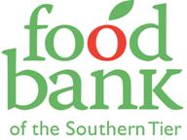

Questions? Call the Food Bank of the Southern Tier 607-796-6061

**Save the Date!**

The next Kids’ Farmers Market will be held Day, Date at Time at Location.



Questions? Call the Food Bank of the Southern Tier 607-796-6061

**Save the Date!**

The next Kids’ Farmers Market will be held Day, Date at Time at Location.



Questions? Call the Food Bank of the Southern Tier 607-796-6061

**Save the Date!**

The next Kids’ Farmers Market will be held Day, Date at Time at Location.



Questions? Call the Food Bank of the Southern Tier 607-796-6061